Project - Phase 2 Deliverables

2024-10-12

# Load necessary libraries  
library(tidyverse)

## ── Attaching core tidyverse packages ──────────────────────── tidyverse 2.0.0 ──  
## ✔ dplyr 1.1.4 ✔ readr 2.1.5  
## ✔ forcats 1.0.0 ✔ stringr 1.5.1  
## ✔ ggplot2 3.5.1 ✔ tibble 3.2.1  
## ✔ lubridate 1.9.3 ✔ tidyr 1.3.1  
## ✔ purrr 1.0.2   
## ── Conflicts ────────────────────────────────────────── tidyverse_conflicts() ──  
## ✖ dplyr::filter() masks stats::filter()  
## ✖ dplyr::lag() masks stats::lag()  
## ℹ Use the conflicted package (<http://conflicted.r-lib.org/>) to force all conflicts to become errors

library(tidymodels)

## ── Attaching packages ────────────────────────────────────── tidymodels 1.2.0 ──  
## ✔ broom 1.0.6 ✔ rsample 1.2.1  
## ✔ dials 1.3.0 ✔ tune 1.2.1  
## ✔ infer 1.0.7 ✔ workflows 1.1.4  
## ✔ modeldata 1.4.0 ✔ workflowsets 1.1.0  
## ✔ parsnip 1.2.1 ✔ yardstick 1.3.1  
## ✔ recipes 1.1.0   
## ── Conflicts ───────────────────────────────────────── tidymodels_conflicts() ──  
## ✖ scales::discard() masks purrr::discard()  
## ✖ dplyr::filter() masks stats::filter()  
## ✖ recipes::fixed() masks stringr::fixed()  
## ✖ dplyr::lag() masks stats::lag()  
## ✖ yardstick::spec() masks readr::spec()  
## ✖ recipes::step() masks stats::step()  
## • Dig deeper into tidy modeling with R at https://www.tmwr.org

library(VIM)

## Loading required package: colorspace  
## Loading required package: grid  
## VIM is ready to use.  
##   
## Suggestions and bug-reports can be submitted at: https://github.com/statistikat/VIM/issues  
##   
## Attaching package: 'VIM'  
##   
## The following object is masked from 'package:recipes':  
##   
## prepare  
##   
## The following object is masked from 'package:datasets':  
##   
## sleep

library(caret)

## Loading required package: lattice  
##   
## Attaching package: 'caret'  
##   
## The following objects are masked from 'package:yardstick':  
##   
## precision, recall, sensitivity, specificity  
##   
## The following object is masked from 'package:purrr':  
##   
## lift

library(GGally)

## Registered S3 method overwritten by 'GGally':  
## method from   
## +.gg ggplot2

library(mice)

##   
## Attaching package: 'mice'  
##   
## The following object is masked from 'package:stats':  
##   
## filter  
##   
## The following objects are masked from 'package:base':  
##   
## cbind, rbind

library(yardstick)

train_data = read_csv("/Users/ellismacbookair/Library/Mobile Documents/com~apple~CloudDocs/Documents/UNCW MBA/BAN - 502 Pred Analytics/product-failure-kaggle-competition-fall-24/train.csv")

## Rows: 26570 Columns: 26  
## ── Column specification ────────────────────────────────────────────────────────  
## Delimiter: ","  
## chr (4): product_code, attribute_0, attribute_1, failure  
## dbl (22): id, loading, attribute_2, attribute_3, measurement_0, measurement_...  
##   
## ℹ Use `spec()` to retrieve the full column specification for this data.  
## ℹ Specify the column types or set `show_col_types = FALSE` to quiet this message.

# Checking structure of the dataset  
str(train_data)

## spc_tbl_ [26,570 × 26] (S3: spec_tbl_df/tbl_df/tbl/data.frame)  
## $ id : num [1:26570] 0 1 2 3 4 5 6 7 8 9 ...  
## $ product_code : chr [1:26570] "A" "A" "A" "A" ...  
## $ loading : num [1:26570] 80.1 84.9 82.4 101.1 188.1 ...  
## $ attribute_0 : chr [1:26570] "material_7" "material_7" "material_7" "material_7" ...  
## $ attribute_1 : chr [1:26570] "material_8" "material_8" "material_8" "material_8" ...  
## $ attribute_2 : num [1:26570] 9 9 9 9 9 9 9 9 9 9 ...  
## $ attribute_3 : num [1:26570] 5 5 5 5 5 5 5 5 5 5 ...  
## $ measurement_0 : num [1:26570] 7 14 12 13 9 11 12 4 9 10 ...  
## $ measurement_1 : num [1:26570] 8 3 1 2 2 4 2 8 6 4 ...  
## $ measurement_2 : num [1:26570] 4 3 5 6 8 0 4 8 5 7 ...  
## $ measurement_3 : num [1:26570] 18 18.2 18.1 17.3 19.3 ...  
## $ measurement_4 : num [1:26570] 12.5 11.5 11.7 11.2 12.9 ...  
## $ measurement_5 : num [1:26570] 15.7 17.7 16.7 18.6 17 ...  
## $ measurement_6 : num [1:26570] 19.3 17.9 18.2 18.3 15.7 ...  
## $ measurement_7 : num [1:26570] 11.7 12.7 12.7 12.6 11.3 ...  
## $ measurement_8 : num [1:26570] 20.2 17.9 18.3 19.1 18.1 ...  
## $ measurement_9 : num [1:26570] 10.7 12.4 12.7 12.5 10.3 ...  
## $ measurement_10: num [1:26570] 15.9 17.9 15.6 16.3 17.1 ...  
## $ measurement_11: num [1:26570] 17.6 17.9 NA 18.4 19.9 ...  
## $ measurement_12: num [1:26570] 15.2 11.8 13.8 10 12.4 ...  
## $ measurement_13: num [1:26570] 15 14.7 16.7 15.2 16.2 ...  
## $ measurement_14: num [1:26570] NA 15.4 18.6 15.6 12.8 ...  
## $ measurement_15: num [1:26570] 13 14.4 14.1 16.2 13.2 ...  
## $ measurement_16: num [1:26570] 14.7 15.6 17.9 17.2 16.4 ...  
## $ measurement_17: num [1:26570] 764 682 663 826 580 ...  
## $ failure : chr [1:26570] "No" "No" "No" "No" ...  
## - attr(*, "spec")=  
## .. cols(  
## .. id = col_double(),  
## .. product_code = col_character(),  
## .. loading = col_double(),  
## .. attribute_0 = col_character(),  
## .. attribute_1 = col_character(),  
## .. attribute_2 = col_double(),  
## .. attribute_3 = col_double(),  
## .. measurement_0 = col_double(),  
## .. measurement_1 = col_double(),  
## .. measurement_2 = col_double(),  
## .. measurement_3 = col_double(),  
## .. measurement_4 = col_double(),  
## .. measurement_5 = col_double(),  
## .. measurement_6 = col_double(),  
## .. measurement_7 = col_double(),  
## .. measurement_8 = col_double(),  
## .. measurement_9 = col_double(),  
## .. measurement_10 = col_double(),  
## .. measurement_11 = col_double(),  
## .. measurement_12 = col_double(),  
## .. measurement_13 = col_double(),  
## .. measurement_14 = col_double(),  
## .. measurement_15 = col_double(),  
## .. measurement_16 = col_double(),  
## .. measurement_17 = col_double(),  
## .. failure = col_character()  
## .. )  
## - attr(*, "problems")=<externalptr>

head(train_data)

## # A tibble: 6 × 26  
## id product_code loading attribute_0 attribute_1 attribute_2 attribute_3  
## <dbl> <chr> <dbl> <chr> <chr> <dbl> <dbl>  
## 1 0 A 80.1 material_7 material_8 9 5  
## 2 1 A 84.9 material_7 material_8 9 5  
## 3 2 A 82.4 material_7 material_8 9 5  
## 4 3 A 101. material_7 material_8 9 5  
## 5 4 A 188. material_7 material_8 9 5  
## 6 5 A 75.4 material_7 material_8 9 5  
## # ℹ 19 more variables: measurement_0 <dbl>, measurement_1 <dbl>,  
## # measurement_2 <dbl>, measurement_3 <dbl>, measurement_4 <dbl>,  
## # measurement_5 <dbl>, measurement_6 <dbl>, measurement_7 <dbl>,  
## # measurement_8 <dbl>, measurement_9 <dbl>, measurement_10 <dbl>,  
## # measurement_11 <dbl>, measurement_12 <dbl>, measurement_13 <dbl>,  
## # measurement_14 <dbl>, measurement_15 <dbl>, measurement_16 <dbl>,  
## # measurement_17 <dbl>, failure <chr>

# Create a bar plot for the failure variable  
ggplot(train_data, aes(x = failure)) +  
 geom_bar(fill = c("purple", "orange")) + # Colors for 'No' and 'Yes'  
 labs(title = "Distribution of Failure Variable",   
 x = "Failure",   
 y = "Count") + # Add labels for axes  
 theme_minimal(base_size = 14) # Use minimal theme for clean layout

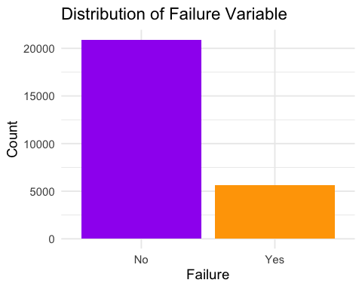

# Calculate the number of failures and non-failures  
failure_counts = train_data %>% count(failure)  
  
# Calculate percentages  
failure_counts = failure_counts %>%  
 mutate(percent = n / sum(n) * 100)  
  
# Show the breakdown in console  
failure_counts

## # A tibble: 2 × 3  
## failure n percent  
## <chr> <int> <dbl>  
## 1 No 20921 78.7  
## 2 Yes 5649 21.3

# Plot missing data pattern with VIM package  
aggr(train_data, col=c('purple','orange'), numbers=TRUE, sortVars=TRUE, labels=names(train_data), cex.axis=.7, gap=3, ylab=c("Missing data","Pattern"))

## Warning in plot.aggr(res, ...): not enough vertical space to display  
## frequencies (too many combinations)

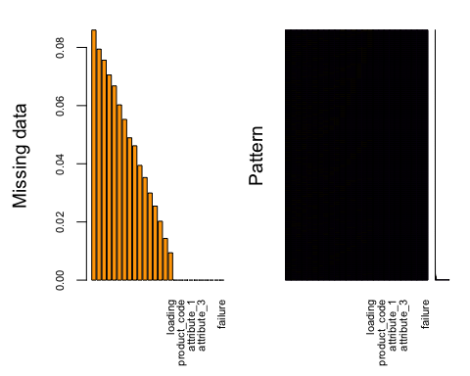

##   
## Variables sorted by number of missings:   
## Variable Count  
## measurement_17 0.085961611  
## measurement_16 0.079412872  
## measurement_15 0.075611592  
## measurement_14 0.070530674  
## measurement_13 0.066767030  
## measurement_12 0.060255928  
## measurement_11 0.055250282  
## measurement_10 0.048927362  
## measurement_9 0.046179902  
## measurement_8 0.039442981  
## measurement_7 0.035265337  
## measurement_6 0.029958600  
## measurement_5 0.025442228  
## measurement_4 0.020248400  
## measurement_3 0.014339481  
## loading 0.009409108  
## id 0.000000000  
## product_code 0.000000000  
## attribute_0 0.000000000  
## attribute_1 0.000000000  
## attribute_2 0.000000000  
## attribute_3 0.000000000  
## measurement_0 0.000000000  
## measurement_1 0.000000000  
## measurement_2 0.000000000  
## failure 0.000000000

# Perform missing data imputation using mice  
imputed_data = mice(train_data, m = 5, method = 'pmm', seed = 123)

##   
## iter imp variable  
## 1 1 loading measurement_3 measurement_4 measurement_5 measurement_6 measurement_7 measurement_8 measurement_9 measurement_10 measurement_11 measurement_12 measurement_13 measurement_14 measurement_15 measurement_16 measurement_17  
## 1 2 loading measurement_3 measurement_4 measurement_5 measurement_6 measurement_7 measurement_8 measurement_9 measurement_10 measurement_11 measurement_12 measurement_13 measurement_14 measurement_15 measurement_16 measurement_17  
## 1 3 loading measurement_3 measurement_4 measurement_5 measurement_6 measurement_7 measurement_8 measurement_9 measurement_10 measurement_11 measurement_12 measurement_13 measurement_14 measurement_15 measurement_16 measurement_17  
## 1 4 loading measurement_3 measurement_4 measurement_5 measurement_6 measurement_7 measurement_8 measurement_9 measurement_10 measurement_11 measurement_12 measurement_13 measurement_14 measurement_15 measurement_16 measurement_17  
## 1 5 loading measurement_3 measurement_4 measurement_5 measurement_6 measurement_7 measurement_8 measurement_9 measurement_10 measurement_11 measurement_12 measurement_13 measurement_14 measurement_15 measurement_16 measurement_17  
## 2 1 loading measurement_3 measurement_4 measurement_5 measurement_6 measurement_7 measurement_8 measurement_9 measurement_10 measurement_11 measurement_12 measurement_13 measurement_14 measurement_15 measurement_16 measurement_17  
## 2 2 loading measurement_3 measurement_4 measurement_5 measurement_6 measurement_7 measurement_8 measurement_9 measurement_10 measurement_11 measurement_12 measurement_13 measurement_14 measurement_15 measurement_16 measurement_17  
## 2 3 loading measurement_3 measurement_4 measurement_5 measurement_6 measurement_7 measurement_8 measurement_9 measurement_10 measurement_11 measurement_12 measurement_13 measurement_14 measurement_15 measurement_16 measurement_17  
## 2 4 loading measurement_3 measurement_4 measurement_5 measurement_6 measurement_7 measurement_8 measurement_9 measurement_10 measurement_11 measurement_12 measurement_13 measurement_14 measurement_15 measurement_16 measurement_17  
## 2 5 loading measurement_3 measurement_4 measurement_5 measurement_6 measurement_7 measurement_8 measurement_9 measurement_10 measurement_11 measurement_12 measurement_13 measurement_14 measurement_15 measurement_16 measurement_17  
## 3 1 loading measurement_3 measurement_4 measurement_5 measurement_6 measurement_7 measurement_8 measurement_9 measurement_10 measurement_11 measurement_12 measurement_13 measurement_14 measurement_15 measurement_16 measurement_17  
## 3 2 loading measurement_3 measurement_4 measurement_5 measurement_6 measurement_7 measurement_8 measurement_9 measurement_10 measurement_11 measurement_12 measurement_13 measurement_14 measurement_15 measurement_16 measurement_17  
## 3 3 loading measurement_3 measurement_4 measurement_5 measurement_6 measurement_7 measurement_8 measurement_9 measurement_10 measurement_11 measurement_12 measurement_13 measurement_14 measurement_15 measurement_16 measurement_17  
## 3 4 loading measurement_3 measurement_4 measurement_5 measurement_6 measurement_7 measurement_8 measurement_9 measurement_10 measurement_11 measurement_12 measurement_13 measurement_14 measurement_15 measurement_16 measurement_17  
## 3 5 loading measurement_3 measurement_4 measurement_5 measurement_6 measurement_7 measurement_8 measurement_9 measurement_10 measurement_11 measurement_12 measurement_13 measurement_14 measurement_15 measurement_16 measurement_17  
## 4 1 loading measurement_3 measurement_4 measurement_5 measurement_6 measurement_7 measurement_8 measurement_9 measurement_10 measurement_11 measurement_12 measurement_13 measurement_14 measurement_15 measurement_16 measurement_17  
## 4 2 loading measurement_3 measurement_4 measurement_5 measurement_6 measurement_7 measurement_8 measurement_9 measurement_10 measurement_11 measurement_12 measurement_13 measurement_14 measurement_15 measurement_16 measurement_17  
## 4 3 loading measurement_3 measurement_4 measurement_5 measurement_6 measurement_7 measurement_8 measurement_9 measurement_10 measurement_11 measurement_12 measurement_13 measurement_14 measurement_15 measurement_16 measurement_17  
## 4 4 loading measurement_3 measurement_4 measurement_5 measurement_6 measurement_7 measurement_8 measurement_9 measurement_10 measurement_11 measurement_12 measurement_13 measurement_14 measurement_15 measurement_16 measurement_17  
## 4 5 loading measurement_3 measurement_4 measurement_5 measurement_6 measurement_7 measurement_8 measurement_9 measurement_10 measurement_11 measurement_12 measurement_13 measurement_14 measurement_15 measurement_16 measurement_17  
## 5 1 loading measurement_3 measurement_4 measurement_5 measurement_6 measurement_7 measurement_8 measurement_9 measurement_10 measurement_11 measurement_12 measurement_13 measurement_14 measurement_15 measurement_16 measurement_17  
## 5 2 loading measurement_3 measurement_4 measurement_5 measurement_6 measurement_7 measurement_8 measurement_9 measurement_10 measurement_11 measurement_12 measurement_13 measurement_14 measurement_15 measurement_16 measurement_17  
## 5 3 loading measurement_3 measurement_4 measurement_5 measurement_6 measurement_7 measurement_8 measurement_9 measurement_10 measurement_11 measurement_12 measurement_13 measurement_14 measurement_15 measurement_16 measurement_17  
## 5 4 loading measurement_3 measurement_4 measurement_5 measurement_6 measurement_7 measurement_8 measurement_9 measurement_10 measurement_11 measurement_12 measurement_13 measurement_14 measurement_15 measurement_16 measurement_17  
## 5 5 loading measurement_3 measurement_4 measurement_5 measurement_6 measurement_7 measurement_8 measurement_9 measurement_10 measurement_11 measurement_12 measurement_13 measurement_14 measurement_15 measurement_16 measurement_17

## Warning: Number of logged events: 4

# Plot 2: Distribution of Loading by Failure  
ggplot(train_data, aes(x = failure, y = loading, fill = failure)) +  
 geom_boxplot() +  
 scale_fill_manual(values = c("No" = "purple", "Yes" = "orange")) +  
 labs(title = "Distribution of Loading by Failure", x = "Failure", y = "Loading") +  
 theme_minimal()

## Warning: Removed 250 rows containing non-finite outside the scale range  
## (`stat_boxplot()`).

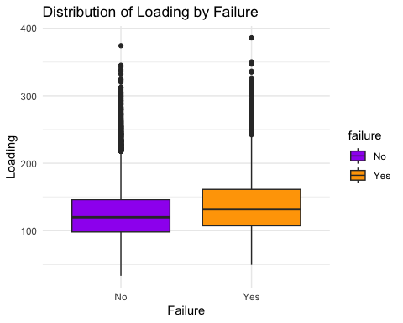

# Plot the distribution of 'loading' with color fill based on 'failure' status  
ggplot(train_data, aes(x = loading, fill = failure)) +  
 geom_histogram(position = "identity", binwidth = 10, color = "orange", alpha = 0.8) +   
 scale_fill_manual(values = c("No" = "purple", "Yes" = "orange")) +  
 labs(title = "Distribution of Loading", x = "Loading", y = "Frequency") +  
 theme_minimal()

## Warning: Removed 250 rows containing non-finite outside the scale range  
## (`stat_bin()`).

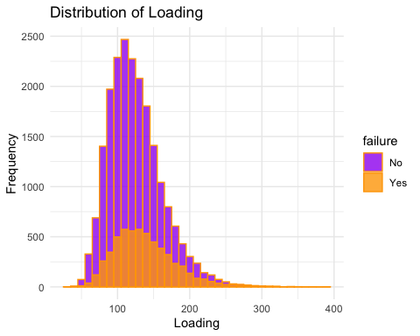

# Convert all character columns to factors  
train_data = train_data %>%  
 mutate_if(is.character, as.factor)

# Set up the logistic regression model  
log_reg_model = logistic_reg() %>%   
 set_engine("glm") %>%   
 set_mode("classification")  
  
# Define the recipe (without pre-prepping)  
recipe = recipe(failure ~ loading + product_code + attribute_0 + attribute_1, data = train_data)  
  
# Create a workflow and add the model and recipe  
log_reg_workflow = workflow() %>%  
 add_model(log_reg_model) %>%  
 add_recipe(recipe)  
  
# Fit the model using the updated data  
log_reg_fit = fit(log_reg_workflow, data = train_data)  
  
# Check the fit summary  
log_reg_fit

## ══ Workflow [trained] ══════════════════════════════════════════════════════════  
## Preprocessor: Recipe  
## Model: logistic_reg()  
##   
## ── Preprocessor ────────────────────────────────────────────────────────────────  
## 0 Recipe Steps  
##   
## ── Model ───────────────────────────────────────────────────────────────────────  
##   
## Call: stats::glm(formula = ..y ~ ., family = stats::binomial, data = data)  
##   
## Coefficients:  
## (Intercept) loading product_codeB   
## -2.227814 0.007631 -0.148892   
## product_codeC product_codeD product_codeE   
## -0.086939 -0.053862 -0.107292   
## attribute_0material_7 attribute_1material_6 attribute_1material_8   
## NA NA NA   
##   
## Degrees of Freedom: 26319 Total (i.e. Null); 26314 Residual  
## (250 observations deleted due to missingness)  
## Null Deviance: 27260   
## Residual Deviance: 26830 AIC: 26840

# Define cross-validation folds  
cv_folds = vfold_cv(train_data, v = 5)  
  
# Perform cross-validation  
log_reg_results = fit_resamples(  
 log_reg_workflow,  
 resamples = cv_folds,  
 metrics = metric_set(accuracy, roc_auc),  
 control = control_resamples(save_pred = TRUE)  
)  
  
# Collect metrics from cross-validation  
collect_metrics(log_reg_results)

## # A tibble: 2 × 6  
## .metric .estimator mean n std_err .config   
## <chr> <chr> <dbl> <int> <dbl> <chr>   
## 1 accuracy binary 0.787 5 0.00168 Preprocessor1_Model1  
## 2 roc_auc binary 0.588 5 0.00211 Preprocessor1_Model1

# Bar chart for product code vs failure  
ggplot(train_data, aes(x = product_code, fill = failure)) +   
 geom_bar(position = "dodge") +   
 scale_fill_manual(values = c("No" = "purple", "Yes" = "orange")) +   
 labs(title = "Product Code vs Failure", x = "Product Code", y = "Count") +  
 theme_minimal()

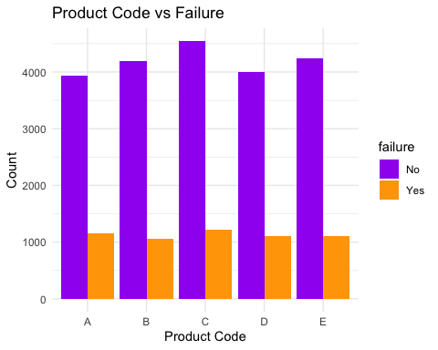

# Bar chart for model performance comparison (optional)  
model_performance = data.frame(  
 Model = rep(c("Logistic Regression", "Classification Tree", "Random Forest"), 2),  
 Metric = rep(c("Accuracy", "AUC"), each = 3),  
 Score = c(0.787, 0.687, 0.800, 0.588, 0.680, 0.850)  
)  
  
ggplot(model_performance, aes(x = Model, y = Score, fill = Metric)) +   
 geom_bar(stat = "identity", position = "dodge") +   
 scale_fill_manual(values = c("Accuracy" = "purple", "AUC" = "orange")) +  
 labs(title = "Model Performance Comparison", x = "Model", y = "Score") +  
 theme_minimal()

